**LAB-5**

**Boolean Simplification, Min-Max Terms Representation & K Maps**

**Name.**

**Equipment:**

Explorer Board

**Software:**

Circuit Maker, Waveforms

**Components:**

IC Type 7408 QUAD two input AND gate

IC Type 7432 Two input OR gate

IC Type 7404One input NOT gate

**Description:**

The solution to a Boolean equation is normally expressed in one of two formats: the sum of group of products (Sum-Of-Products - SOP) or the product of group of sums (Product-of-Sums, or POS).

Minterm: A term that contains all of the input variables joined with an AND gate (or multiplied together) for a "True" output is called a minterm.

Maxterm: A term that contains all of the input variables joined with an OR gate (or added together) for a FALSE output is called a maxterm.

See your last class lecture for more details.

**Objectives:**

* To understand concept of POS and SOP representation
* To understand use and concept of Min and Max terms
* To learn Boolean simplification

**In Lab Tasks**

**Lab Task#1.Consider the given table for the task.**

|  |  |  |  |  |
| --- | --- | --- | --- | --- |
| **Inputs** | | | **Outputs** | |
| **X** | **Y** | **Z** | **M** | **N** |
| 0 | 0 | 0 | 1 | 0 |
| 0 | 0 | 1 | 0 | 1 |
| 0 | 1 | 0 | 0 | 1 |
| 0 | 1 | 1 | 1 | 0 |
| 1 | 0 | 0 | 0 | 0 |
| 1 | 0 | 1 | 1 | 1 |
| 1 | 1 | 0 | 1 | 1 |
| 1 | 1 | 1 | 0 | 0 |

1. List minterm and maxterms of each function.

M:

**Minterms of M=(m0+m3+m5+m6)**

**Maxterms of M=(M1,M2,M4,M7)**

N:

**Minterms of N=(m1+m2+m5+m6)**

**Maxterms of N=(M0,M3,M4,M7)**

1. Express M in sum-of-minterms (SOP) algebraic form.

**X’Y’Z’+XY’Z’+XY’Z+XYZ’**

1. Express N in product-of-maxterms algebraic form.

**(X+Y+Z)+(X+Y’+Z)+(X’+Y+Z)+(X’+Y’+Z’)**

1. Simplify each E and F to minimum number of literals using K-Map (on page) and express your answer below

|  |  |  |  |
| --- | --- | --- | --- |
| **1** |  | **1** |  |
|  | **1** |  | **1** |

|  |  |  |  |
| --- | --- | --- | --- |
|  | **1** |  | **1** |
|  | **1** |  | **1** |

X xor Y XOR Z

|  |  |  |  |
| --- | --- | --- | --- |
|  | **1** |  | **1** |
|  | **1** |  | **1** |

Y XOR Z

**b Task#2.Obtain the truth table of following functions and express each function in SOP and POS form.**

1. (x’ + y)(y+ z’)

|  |  |  |  |  |  |  |  |  |
| --- | --- | --- | --- | --- | --- | --- | --- | --- |
| **X** | **Y** | **Z** | **X’** | **Y’** | **Z’** | **X’+Y** | **Y+Z’** | **D** |
| **0** | **0** | **0** | **1** | **1** | **1** | **1** | **1** | **1** |
| **0** | **0** | **1** | **1** | **1** | **0** | **1** | **0** | **1** |
| **0** | **1** | **0** | **1** | **0** | **1** | **1** | **1** | **1** |
| **0** | **1** | **1** | **1** | **0** | **0** | **1** | **1** | **1** |
| **1** | **0** | **0** | **0** | **1** | **1** | **0** | **1** | **0** |
| **1** | **0** | **1** | **0** | **1** | **0** | **0** | **0** | **1** |
| **1** | **1** | **0** | **0** | **0** | **1** | **1** | **1** | **1** |
| **1** | **1** | **1** | **0** | **0** | **0** | **1** | **1** | **1** |
| **0** | **0** | **0** | **1** | **1** | **1** | **0** | **1** | **1** |
| **0** | **0** | **1** | **1** | **1** | **0** | **1** | **0** | **1** |
| **0** | **1** | **0** | **1** | **0** | **1** | **1** | **1** | **1** |
| **0** | **1** | **1** | **1** | **0** | **0** | **1** | **1** | **1** |
| **1** | **0** | **0** | **0** | **1** | **1** | **0** | **1** | **1** |
| **1** | **0** | **1** | **0** | **1** | **0** | **0** | **0** | **0** |
| **1** | **1** | **0** | **0** | **0** | **1** | **1** | **1** | **1** |
| **1** | **1** | **1** | **0** | **0** | **0** | **1** | **1** | **1** |

1. (xy + z)(y + xz)

**Lab Task#3. Reduce the Boolean expression given below (on page)**

$F\left(A,B\right)= \underline{AB}+\underline{AC}+\underline{A}\underline{B}\underline{C}$

1. Write the reduced expression

**A’+B’+C’**

1. Create and fill the table for both expressions (given and reduced)

|  |  |  |  |
| --- | --- | --- | --- |
| **A’** | **B’** | **C’** | **A’+B’+C’** |
| **1** | **1** | **1** | **0** |
| **1** | **1** | **0** | **1** |
| **1** | **0** | **1** | **1** |
| **1** | **0** | **0** | **1** |
| **0** | **1** | **1** | **1** |
| **0** | **1** | **0** | **1** |
| **0** | **0** | **1** | **1** |
| **0** | **0** | **0** | **1** |
| **1** | **1** | **1** | **1** |
| **1** | **1** | **0** | **1** |
| **1** | **0** | **1** | **1** |
| **1** | **0** | **0** | **1** |
| **0** | **1** | **1** | **1** |
| **0** | **1** | **0** | **1** |
| **0** | **0** | **1** | **1** |
| **0** | **0** | **0** | **1** |

1. Implement both the expressions (given and reduced) on circuit Maker with same inputs (only three common inputs A, B and C) and verify your results.

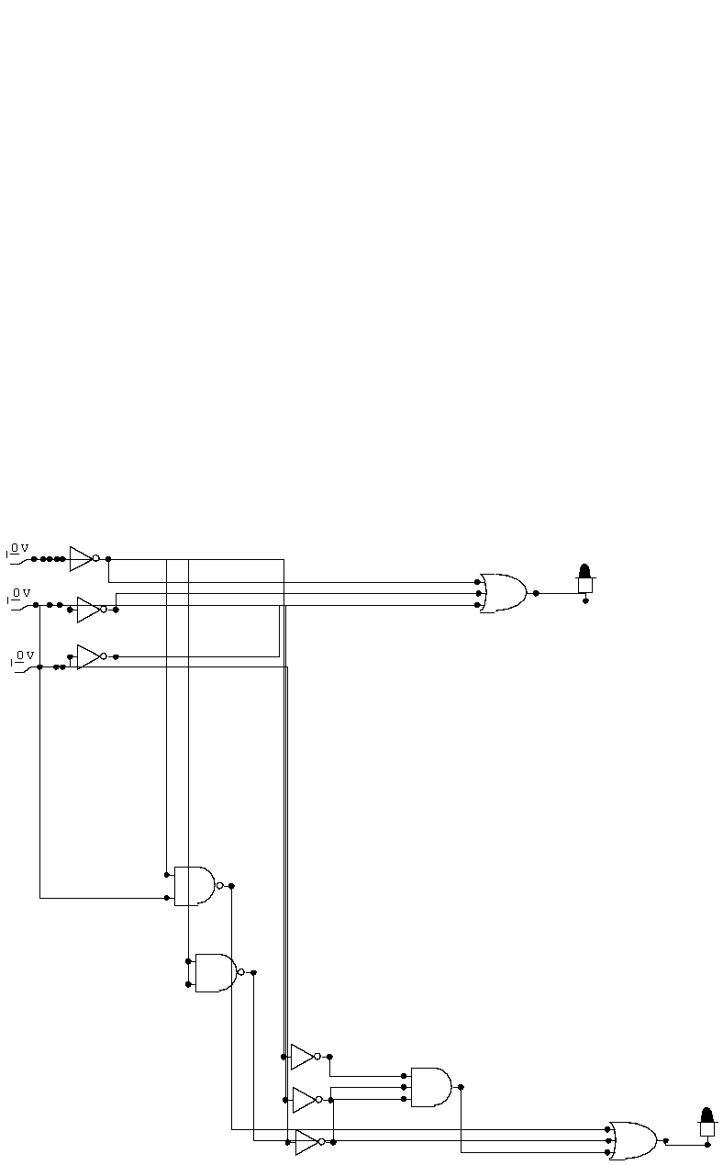

1. Implement both the expressions (given and reduced) on explorer board with same inputs (only three common inputs A, B and C) and verify your results.

**Lab Task#4. A function F is defined by,**

F (A, B, C) = П (0, 2, 5, 7)

1. Draw the truth table for the function

|  |  |  |  |
| --- | --- | --- | --- |
| **A** | **B** | **C** | **F** |
| **0** | **0** | **0** | **0** |
| **0** | **0** | **1** | **1** |
| **0** | **1** | **0** | **0** |
| **0** | **1** | **1** | **1** |
| **1** | **0** | **0** | **1** |
| **1** | **0** | **1** | **0** |
| **1** | **1** | **0** | **1** |
| **1** | **1** | **1** | **0** |

1. Simplify using K-map
2. Write the most simplified equation in SOP and POS form

**POS:**

**(A+C).(A’+C’)**

**SOP:**

**(A.C’)+(A’.C)**

1. Draw the combine (SOP and POS with only three switches) circuit diagram using Circuit Maker

SOP:

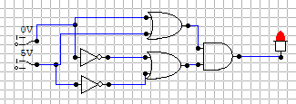

POS:

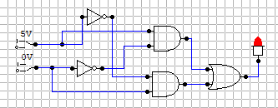

1. Implement SOP expression on Explorer board and verify your result on hardware.

**Lab Task#5.Write the Minterms for the following statements. Fill the truth table and simplify using K-Map.**

1. We have to control an LED with the help of three switches A, B and C. However, there are some conditions as mentioned below;

* LED will be only switched on if all the switches A, B and C are off
* LED will on if C and A are on whereas B is off
* LED will on if only B is on whereas A and C are off
* LED will be off, otherwise

|  |  |  |  |
| --- | --- | --- | --- |
| **A** | **B** | **C** | **F** |
| **0** | **0** | **0** | **1** |
| **0** | **0** | **1** | **0** |
| **0** | **1** | **0** | **1** |
| **0** | **1** | **1** | **0** |
| **1** | **0** | **0** | **0** |
| **1** | **0** | **1** | **1** |
| **1** | **1** | **0** | **0** |
| **1** | **1** | **1** | **0** |

1. We have to control an LED with the help of three switches A, B and C. However, there are some conditions as mentioned below;

* LED will be only switched on if any of the A or C is on whereas B is off.
* LED will on if B or A are on whereas C is on
* LED will on if Aand C is on
* LED will be off, otherwise.

|  |  |  |  |
| --- | --- | --- | --- |
| **A** | **B** | **C** | **F** |
| **0** | **0** | **0** | **1** |
| **0** | **0** | **1** | **0** |
| **0** | **1** | **0** | **1** |
| **0** | **1** | **1** | **0** |
| **1** | **0** | **0** | **1** |
| **1** | **0** | **1** | **1** |
| **1** | **1** | **0** | **1** |
| **1** | **1** | **1** | **0** |

**Implement part 2 expression on explorer board and verify your results.**